**Commodore Port Breakout: User Port Output Rev. 0**

**Module Description**

# Introduction

This assembly provides the edge connector for a Commodore PET User Port. The purpose is connecting it to the 2x12 Breakout board via a ribbon cable.

Every pin of the edge connector is connected to a pin of the (2x13p) box connector/pin header. The “GND” pins of the User Port port are all connected on this board.

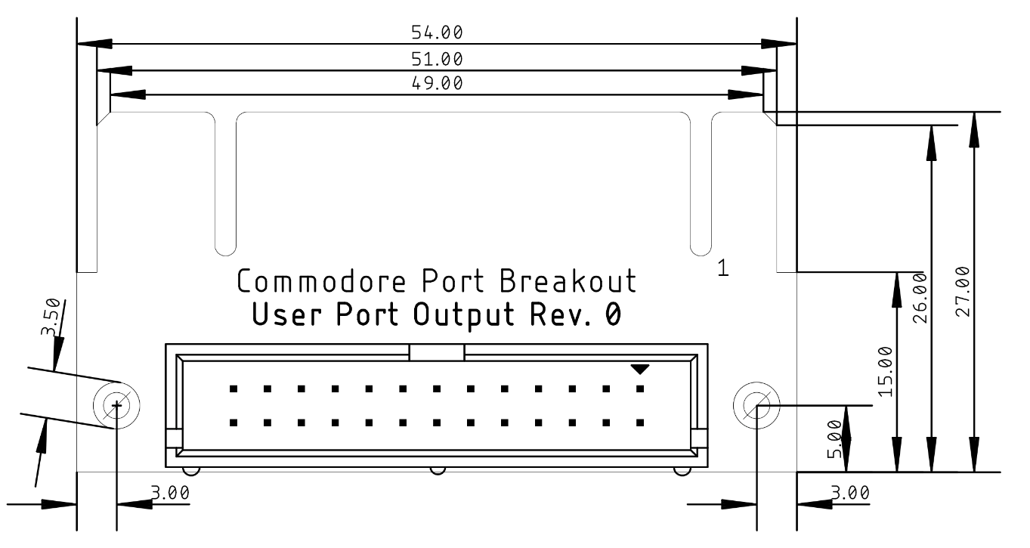

Figure 1: Dimensions of the PCB

# Connector Pinout

J1: 2x13 box connector/pin header 2.54mm pitch.

J2: board edge connector (a structure on the PCB).

|  |  |  |  |  |
| --- | --- | --- | --- | --- |
| J1 | PET User Port | C64 User Port | VIC-20 User Port | J2 |
| 1 | GND | GND | GND | 1 |
| 3 | TVVIDEO | +5V | +5V | 2 |
| 5 | IEEESRQ |  |  | 3 |
| 7 | IEEEEOI | CNT1 | JOY0/PA2 | 4 |
| 9 |  | SP1 | JOY1/PA3 | 5 |
| 11 | TPREAD2 | CNT2 | JOY2/PA4 | 6 |
| 13 | TPWRITE | SP2 | LIGHT PEN/PA5 | 7 |
| 15 | TPREAD1 |  | CASSETTE SWITCH/PA6 | 8 |
| 17 | TVVERT | ATN IN | ATN IN | 9 |
| 19 | TVHOR | 9VAC(1) | 9VAC(1) | 10 |
| 21 |  | 9VAC(2) | 9VAC(2) | 11 |
| 23, 25 | GND | GND | GND | 12 |
| 2 | GND | GND | GND | A |
| 4 | CA1 |  | CB1 | B |
| 6 | PA0 | PB0 | PB0 | C |
| 8 | PA1 | PB1 | PB1 | D |
| 10 | PA2 | PB2 | PB2 | E |
| 12 | PA3 | PB3 | PB3 | F |
| 14 | PA4 | PB4 | PB4 | H |
| 16 | PA5 | PB5 | PB5 | J |
| 18 | PA6 | PB6 | PB6 | K |
| 20 | PA7 | PB7 | PB7 | L |
| 22 | CB2 | PA2 | CB2 | M |
| 24, 26 | GND | GND | GND | N |

# Revision History

## Rev. 0

* Prototype